TUGAS 4

CLASS DIAGRAM RESTAURANT PIZZA

UTAMI BUDI RAHAYU 1127050166

SITI NURPADILAH 1127050148

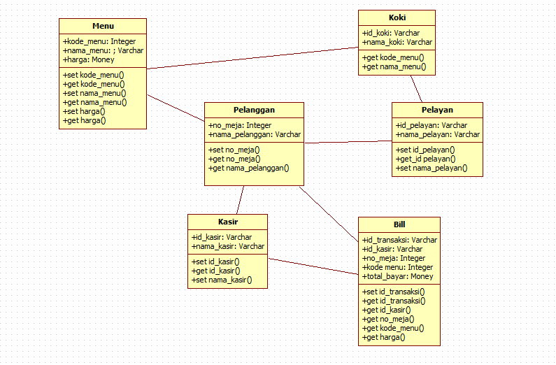KELAS IF-5G